1. **Introduction to the broad theme or challenge.**

The general theme of the project is *Home Automation.*

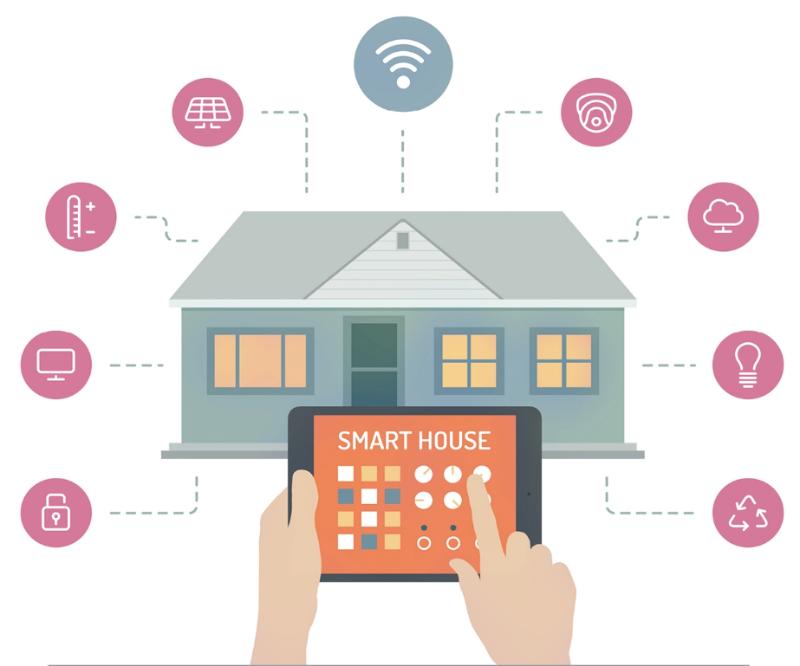

Figure 1(a): Home Automation Systems

Home automation refers to the use of technology to automate and control various aspects of a home, such as lighting, heating, and security. The need for home automation has increased in recent years due to the convenience and energy-saving benefits it offers.

Overall, while home automation offers many benefits, it also presents a number of challenges that need to be carefully considered before implementing it.

Some key benefits of home automation include:

1. Increased convenience: Home automation allows homeowners to control various aspects of their home from a single device, such as a smartphone or tablet, making it easier and more convenient to manage tasks and processes.
2. Improved energy efficiency: Home automation can help to reduce energy consumption by automatically turning off lights and appliances when they are not in use, saving homeowners money on their energy bills.
3. Enhanced security: Home automation systems can be integrated with security cameras and alarms, providing homeowners with peace of mind and added security for their home.
4. Improved accessibility: Home automation can help to make homes more accessible for individuals with disabilities or mobility challenges, allowing them to control various aspects of their home with ease.

The specific domain taken up by our team is *Gardening***.**

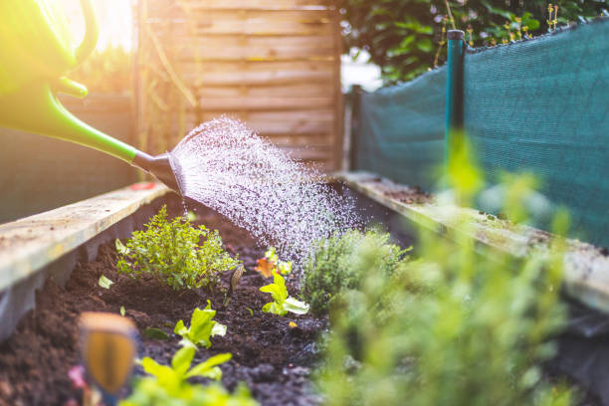

Figure 1(b): Gardening

One of the main challenges of domestic gardening is the time and effort required to maintain a healthy and attractive garden. Gardening can be labour-intensive, especially for those who are busy or have limited physical abilities.

Another challenge is the variability of weather conditions, which can affect the growth and health of plants. Extreme temperatures, drought, and other weather events can damage or kill plants, requiring constant monitoring and intervention.

Another challenge is the need for specialized knowledge and skills to successfully grow and care for plants. Not everyone has the knowledge and expertise to choose the right plants for their climate and conditions, and to provide the necessary care and attention.

Automation in gardening can help to address these challenges by allowing for remote control and monitoring of gardening tasks. Automated systems can provide automated watering, fertilizing, and other essential tasks, reducing the time and effort required for gardening.

Automation can also help to optimize gardening conditions by monitoring weather conditions and providing timely interventions to protect plants from damage. Additionally, automated systems can provide personalized recommendations and advice based on the specific needs of plants and gardens.

Overall, automation in gardening can help to make the hobby more accessible and enjoyable for those with busy lifestyles or limited gardening knowledge and skills.